**[ 2CEIT5PE5: MOBILE APPLICATION DEVELOPMENT]**

Practical: 6



**AIM:** What is Service? Write down types of Service. Create an MP3 player application by using service by following below instructions.

1. Create MainActivity and design according to shown in below image.
2. Create Service Class and implement **[MediaPlayer](https://developer.android.com/reference/android/media/MediaPlayer" \t "_blank)**Object

Submitted By: Pathan Anishkhan Yunuskhan

Enrollment number: 22012022009



**Department of Computer**

**Engineering/Information Technology**

**Practical-6**

**Study:**Service, Types of Service, Drawable Icon Add in project, **[MediaPlayer](https://developer.android.com/reference/android/media/MediaPlayer" \t "_blank),**Add Raw folder, Add mp3 song in raw folder

**Activity\_main.xml:**

<?xml version="1.0" encoding="utf-8"?>  
<androidx.constraintlayout.widget.ConstraintLayout  
 xmlns:android="http://schemas.android.com/apk/res/android"  
 xmlns:app="http://schemas.android.com/apk/res-auto"  
 xmlns:tools="http://schemas.android.com/tools"  
 android:layout\_width="match\_parent"  
 android:layout\_height="match\_parent"  
 tools:context=".MainActivity">

<TextView  
 android:id="@+id/player"  
 android:layout\_width="wrap\_content"  
 android:layout\_height="wrap\_content"  
 android:layout\_marginTop="40dp"  
 android:text="MP3 Player"  
 android:textSize="20dp"  
 android:textStyle="bold"  
 app:layout\_constraintEnd\_toEndOf="parent"  
 app:layout\_constraintStart\_toStartOf="parent"  
 app:layout\_constraintTop\_toTopOf="parent" />  
  
 <com.google.android.material.card.MaterialCardView  
 android:id="@+id/card1"  
 android:layout\_width="380dp"  
 android:layout\_height="380dp"  
 app:layout\_constraintStart\_toStartOf="parent"  
 app:layout\_constraintTop\_toBottomOf="@id/player"  
 app:layout\_constraintEnd\_toEndOf="parent"  
 android:layout\_marginTop="20dp"  
 app:cardCornerRadius="20dp"  
 app:cardElevation="20dp">  
 <ImageView  
 android:layout\_width="match\_parent"  
 android:layout\_height="match\_parent"  
 android:src="@drawable/img"  
 android:scaleType="fitXY" />  
 </com.google.android.material.card.MaterialCardView>  
  
 <com.google.android.material.card.MaterialCardView  
 android:id="@+id/card2"  
 android:layout\_width="380dp"  
 android:layout\_height="170dp"  
 android:layout\_marginTop="20dp"  
 app:cardCornerRadius="20dp"  
 app:cardElevation="20dp"  
 app:layout\_constraintEnd\_toEndOf="parent"  
 app:layout\_constraintStart\_toStartOf="parent"  
 app:layout\_constraintTop\_toBottomOf="@id/card1">  
 <androidx.constraintlayout.widget.ConstraintLayout  
 android:id="@+id/nestedConstraint"  
 android:layout\_width="match\_parent"  
 android:layout\_height="match\_parent">  
  
 <TextView  
 android:layout\_width="wrap\_content"  
 android:layout\_height="wrap\_content"  
 android:text="Dosi Music Video"  
 android:textSize="22dp"  
 android:textStyle="bold"  
  
 app:layout\_constraintStart\_toStartOf="parent"  
 app:layout\_constraintTop\_toTopOf="parent"  
 android:layout\_marginLeft="20dp"  
 android:layout\_marginTop="20dp"/>  
  
 <com.google.android.material.floatingactionbutton.FloatingActionButton  
 android:id="@+id/shuffle"  
 android:layout\_width="wrap\_content"  
 android:layout\_height="wrap\_content"  
 android:src="@drawable/shuffle"  
 android:tintMode="@color/white"  
 android:backgroundTint="#675F5F"  
 app:fabCustomSize="45dp"  
 app:layout\_constraintStart\_toStartOf="parent"  
 app:layout\_constraintTop\_toTopOf="parent"  
 android:layout\_marginTop="82dp"  
 android:layout\_marginLeft="23dp" />  
 <com.google.android.material.floatingactionbutton.FloatingActionButton  
 android:id="@+id/previous"  
 android:layout\_width="wrap\_content"  
 android:layout\_height="wrap\_content"  
 android:src="@drawable/skipprevious"  
 app:fabCustomSize="55dp"  
 android:tintMode="@color/white"  
 android:backgroundTint="#675F5F"  
 app:layout\_constraintStart\_toStartOf="parent"  
 app:layout\_constraintTop\_toTopOf="parent"  
 android:layout\_marginTop="78dp"  
 android:layout\_marginLeft="81dp" />  
 <com.google.android.material.floatingactionbutton.FloatingActionButton  
 android:id="@+id/play"  
 android:layout\_width="wrap\_content"  
 android:layout\_height="wrap\_content"  
 android:tintMode="@color/white"  
 android:backgroundTint="#771919"  
 android:src="@drawable/baseline\_play\_arrow\_24"  
 app:fabCustomSize="70dp"  
 app:layout\_constraintStart\_toStartOf="parent"  
 app:layout\_constraintTop\_toTopOf="parent"  
 android:layout\_marginTop="70dp"  
 android:layout\_marginLeft="148dp"  
 />  
 <com.google.android.material.floatingactionbutton.FloatingActionButton  
 android:id="@+id/next"  
 android:layout\_width="wrap\_content"  
 android:layout\_height="wrap\_content"  
 android:tintMode="@color/white"  
 android:backgroundTint="#675F5F"  
 android:src="@drawable/baseline\_skip\_next\_24"  
 app:fabCustomSize="55dp"  
 app:layout\_constraintStart\_toStartOf="parent"  
 app:layout\_constraintTop\_toTopOf="parent"  
 android:layout\_marginTop="78dp"  
 android:layout\_marginLeft="232dp" />  
 <com.google.android.material.floatingactionbutton.FloatingActionButton  
 android:id="@+id/stop"  
 android:layout\_width="wrap\_content"  
  
 android:layout\_height="wrap\_content"  
 android:tintMode="@color/white"  
 android:backgroundTint="#675F5F"  
 android:src="@drawable/stop"  
 app:fabCustomSize="45dp"  
 app:layout\_constraintStart\_toStartOf="parent"  
 app:layout\_constraintTop\_toTopOf="parent"  
 android:layout\_marginTop="82dp"  
 android:layout\_marginLeft="298dp" />  
 </androidx.constraintlayout.widget.ConstraintLayout>  
 </com.google.android.material.card.MaterialCardView>  
</androidx.constraintlayout.widget.ConstraintLayout>

**MainActivity.kt:-**

package com.example.mad\_6\_22012022009

import android.content.Intent

import android.media.AudioAttributes

import android.media.MediaPlayer

import android.net.Uri

import androidx.appcompat.app.AppCompatActivity

import android.os.Bundle

import com.google.android.material.floatingactionbutton.FloatingActionButton

class MainActivity : AppCompatActivity() {

var flag=0;

override fun onCreate(savedInstanceState: Bundle?) {

super.onCreate(savedInstanceState)

setContentView(R.layout.activity\_main)

var playAudio:FloatingActionButton=findViewById<FloatingActionButton>(R.id.play);

playAudio.setOnClickListener { play();

val b:FloatingActionButton=findViewById<FloatingActionButton>(R.id.play);

if(flag==0){

b.setImageResource(R.drawable.baseline\_pause\_24);

flag=1;

}

else{

b.setImageResource(R.drawable.baseline\_play\_arrow\_24);

flag=0;

}

}

var stopAudio:FloatingActionButton=findViewById<FloatingActionButton>(R.id.stop);

stopAudio.setOnClickListener { stop() };

val b:FloatingActionButton=playAudio;

}

fun play(){

Intent(applicationContext,MyService::class.java).putExtra(MyService.PLAYERKEY, MyService.PLAYERVALUE).apply { startService(this) };

}

fun stop(){

Intent(applicationContext,MyService::class.java).putExtra(MyService.PLAYERKEY, MyService.PLAYERVALUE).apply { stopService(this) };

}

}

**MyService.kt:-**

package com.example.mad\_6\_22012022009  
import android.app.Service  
import android.content.Intent  
import android.media.MediaPlayer  
import android.os.IBinder  
  
class MyService : Service() {  
 lateinit var player:MediaPlayer;  
 companion object{  
 val PLAYERKEY="service"  
 val PLAYERVALUE="play/pause"}  
 override fun onBind(intent: Intent): IBinder {  
 *TODO*("Return the communication channel to the service.")  
 }  
 override fun onStartCommand(intent: Intent?, flags: Int, startId: Int): Int {  
 if(!this::player.*isInitialized*){  
 player= MediaPlayer.create(this,R.raw.*jawan*);  
 }  
 if(intent!=null){  
 val datavalue=intent.getStringExtra(PLAYERKEY)  
 if(datavalue== PLAYERVALUE){  
 if(!player.*isPlaying*) {  
 player.start();}  
 else {  
 player.pause();  
 } } }  
 else{  
 player.stop();  
 }  
 return *START\_STICKY*;  
 }  
 override fun onDestroy() {  
 player.stop();  
 super.onDestroy()  
 }}

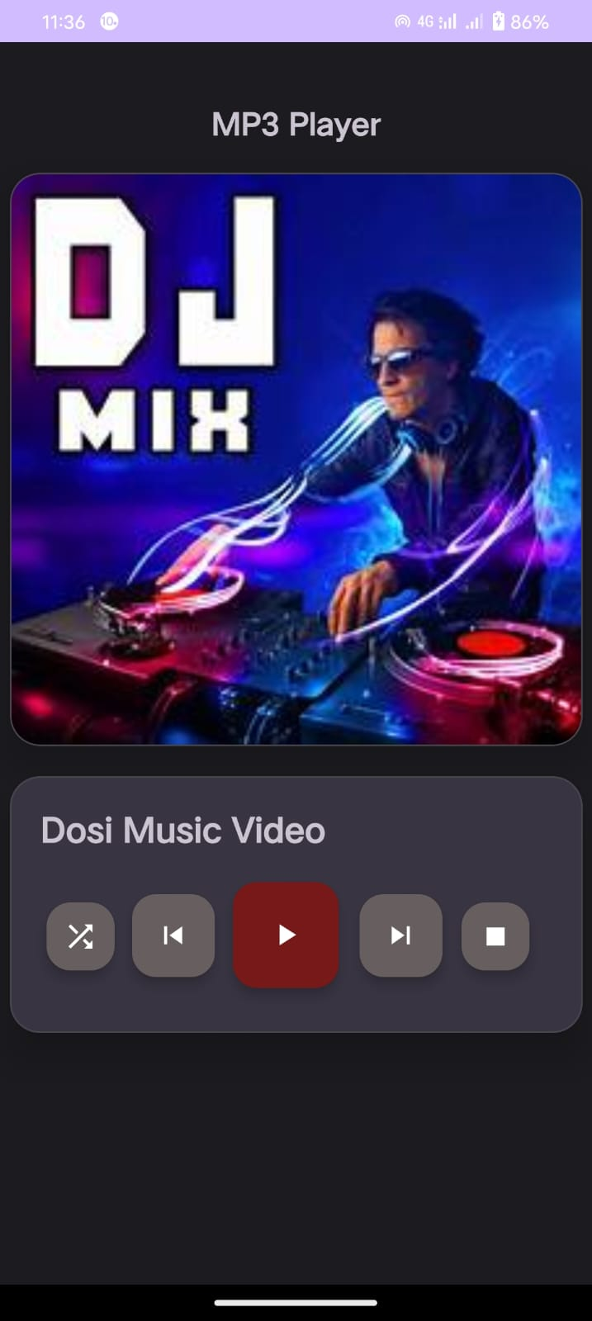**Output:**   
 